**1. Fibonacci Series using recursion.**

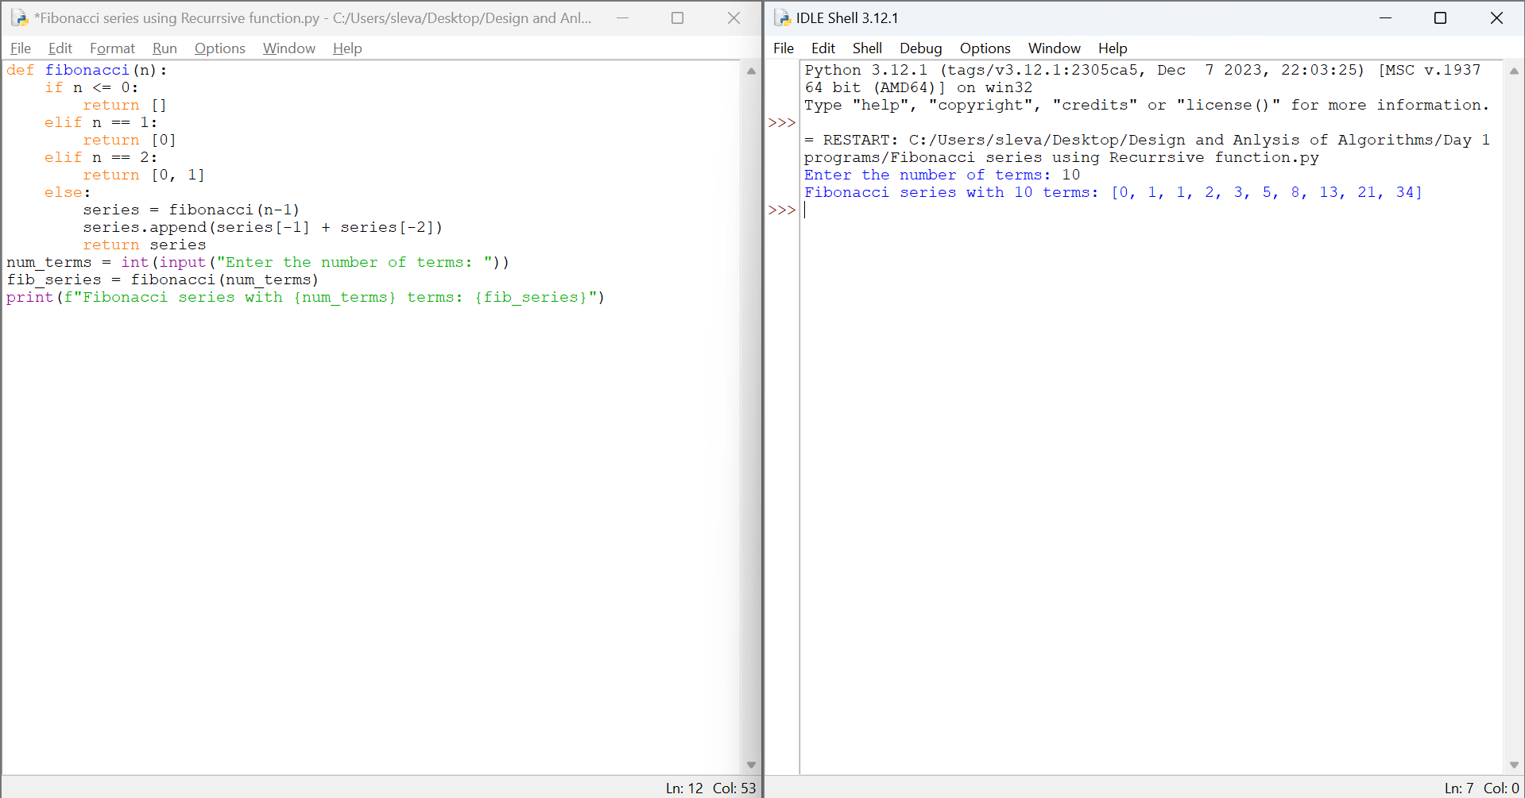

**2. Armstrong or not using recursive function.**

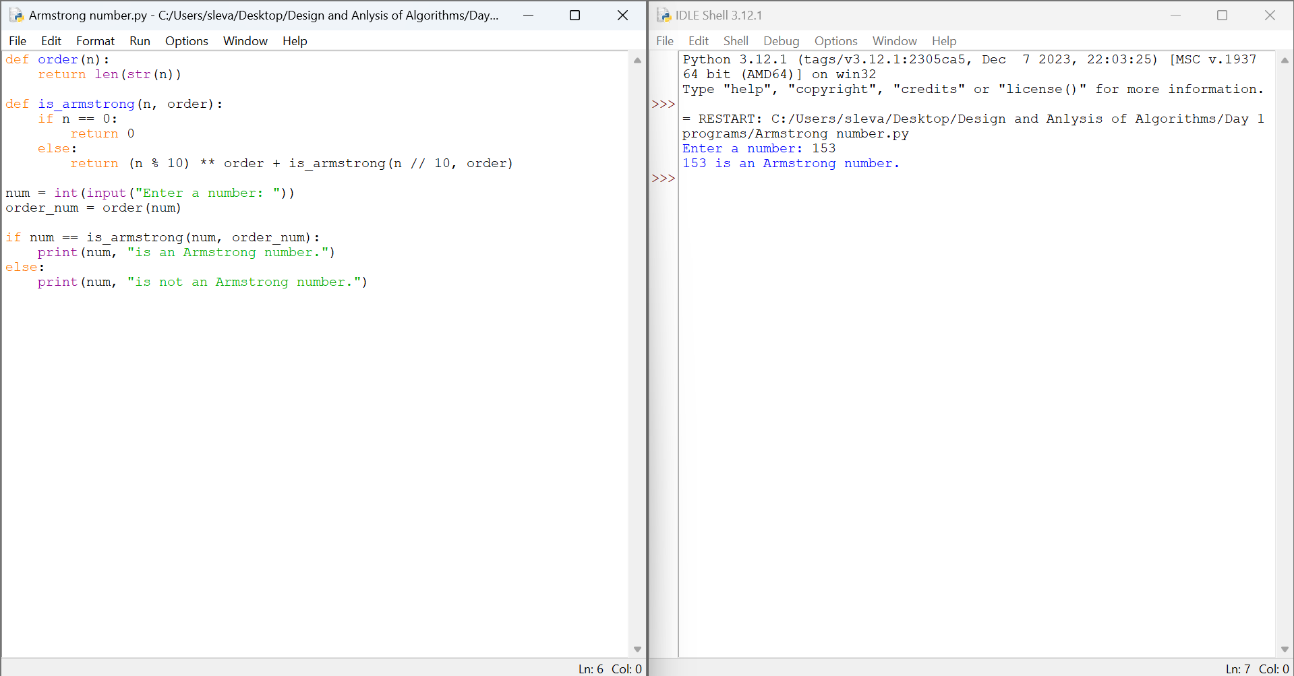

**3. GCD of Two numbers using Recursion**

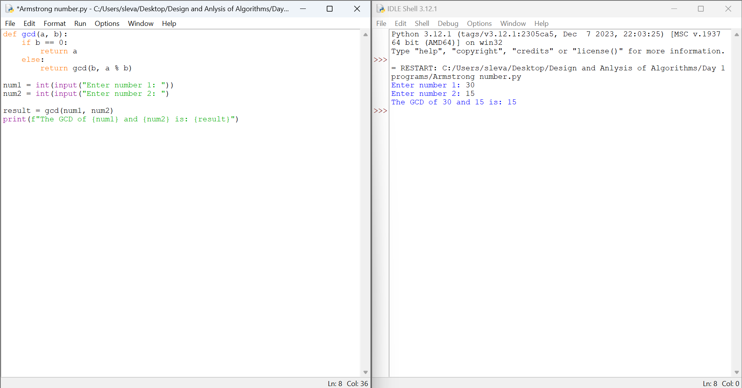

**4. Largest Element in an Array**

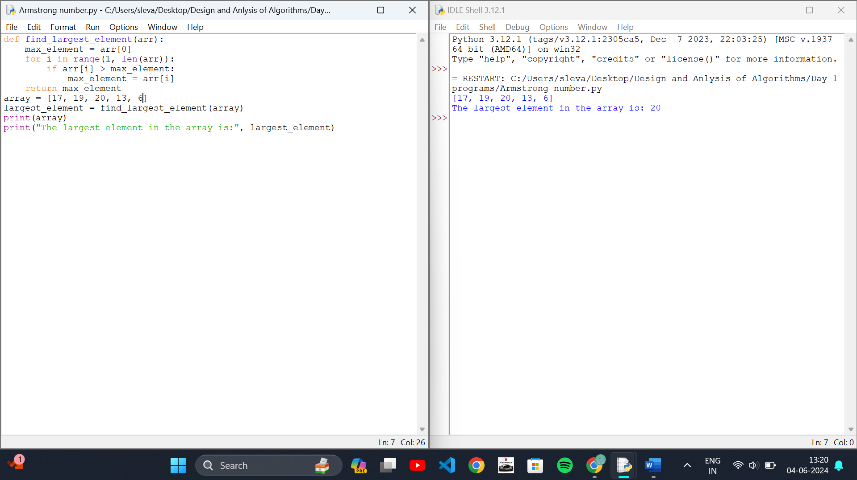

**5. Factorial of a number using recursion**

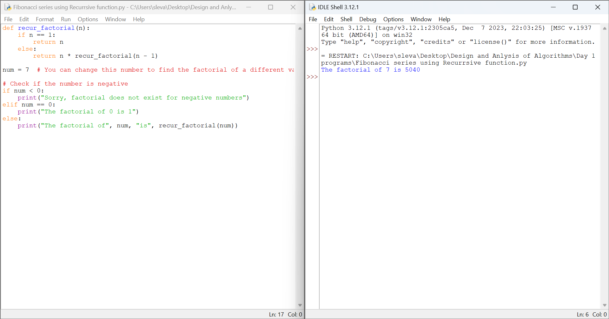

**6. copy one string to another using recursion**

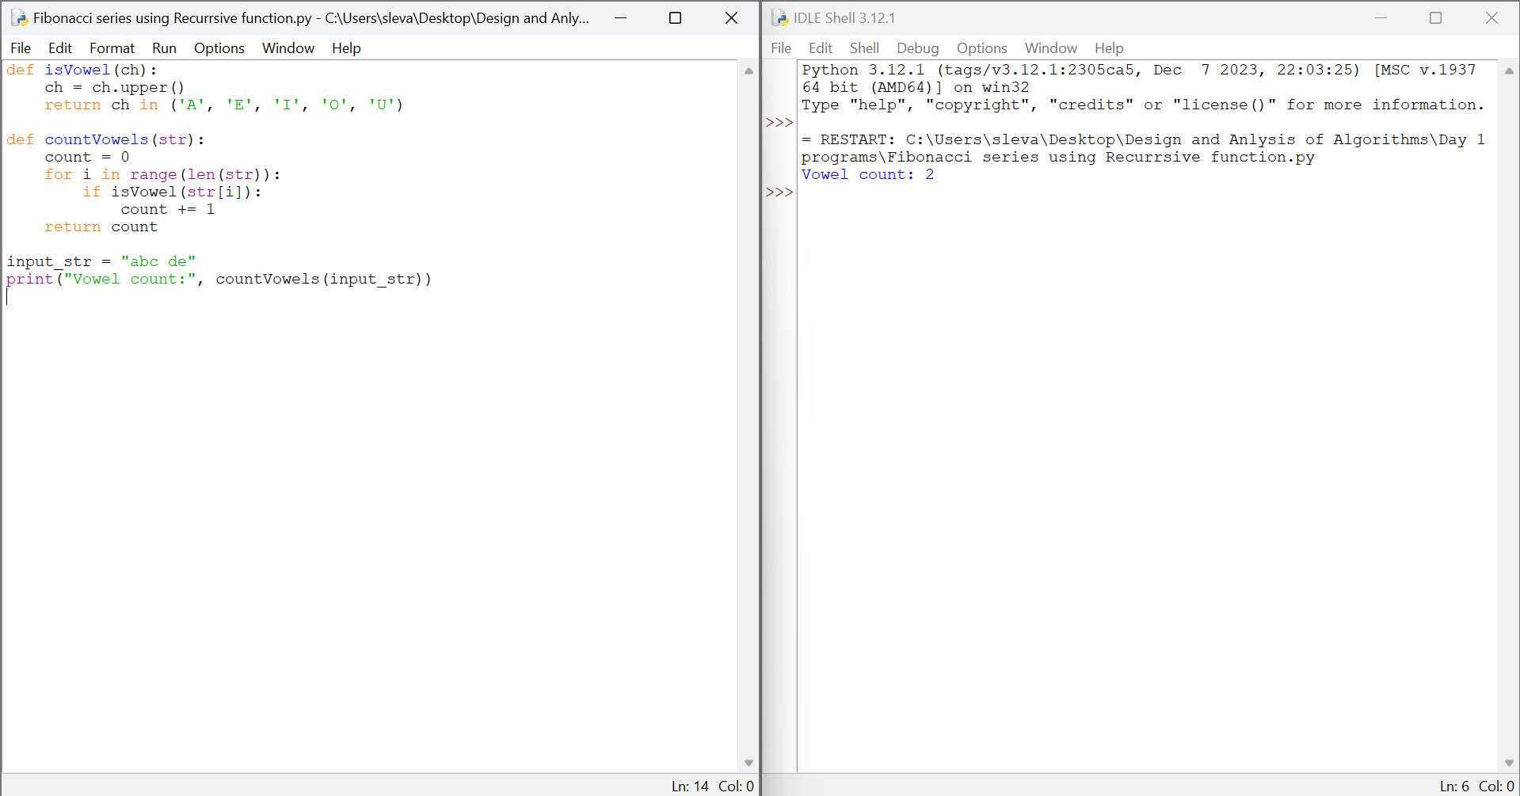

**7. Reverse a string using Recursion**

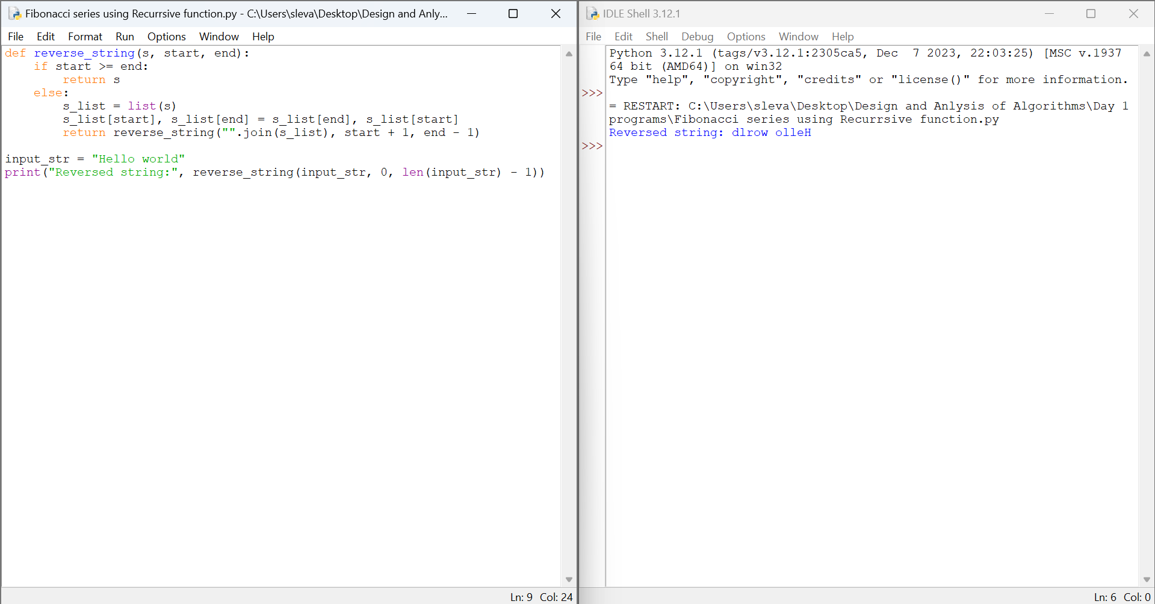

**8. Generate all the prime numbers using recursion**

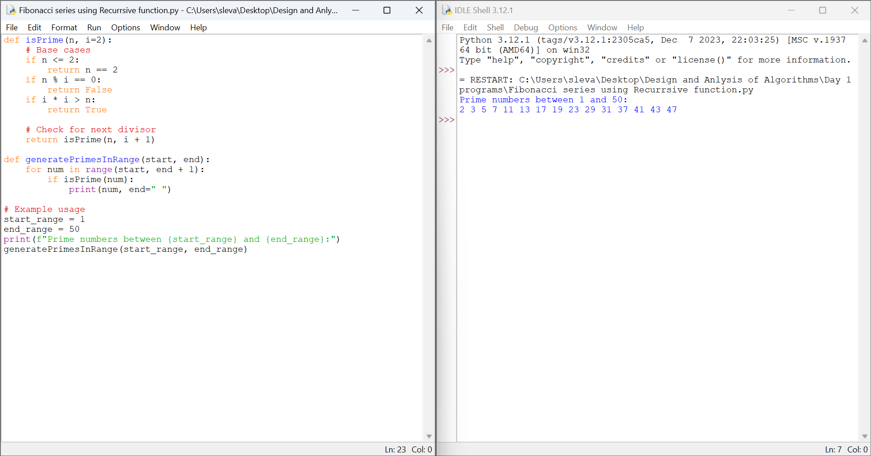

**9**. **Check a number is a prime number or not using recursion.**

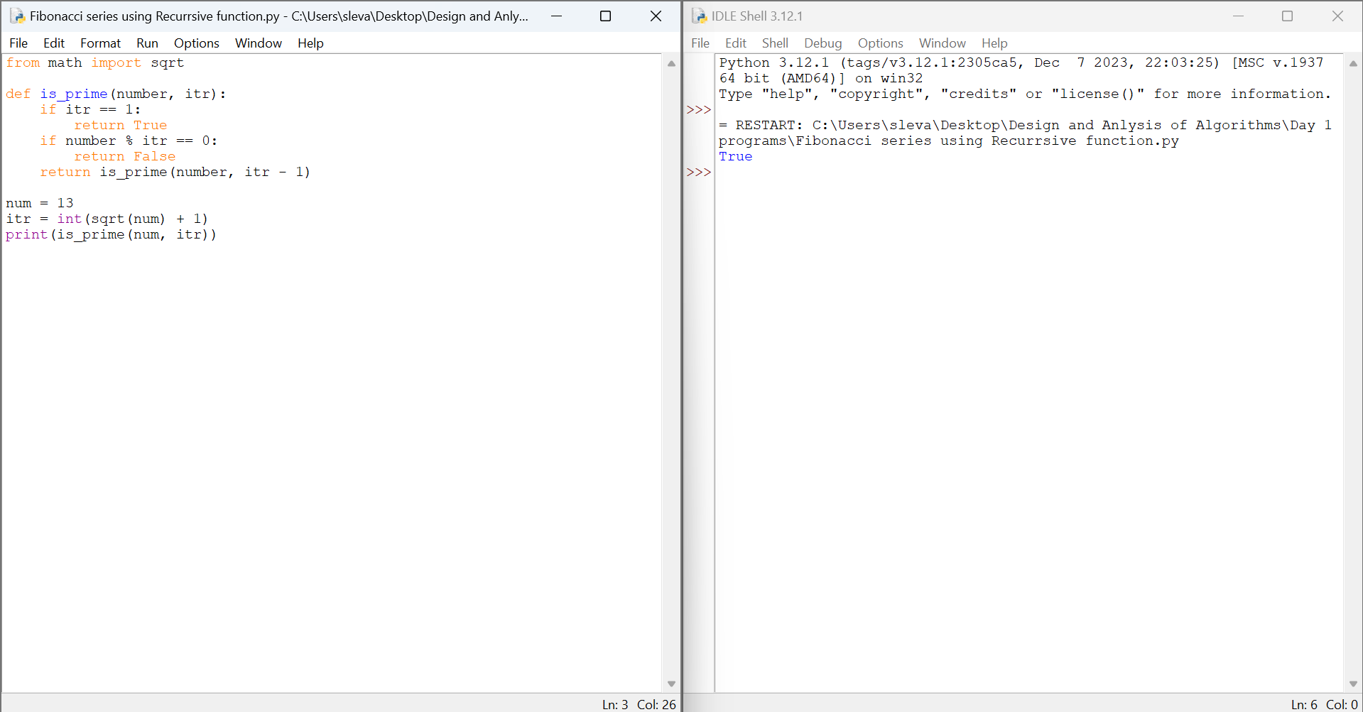

**10.** **Given String is Palindrome or not using recursion**

